**Instructions**

1. Login from root using the command **“sudo –i”**
2. Then use these commands (for colors) :
3. **#PS1='[\u@\h \W]\$ ' # Default**
4. **PS1='\[\e[1;31m\][\u@\h \W]\$\[\e[0m\]** '
5. **PS1='\[\e[0;31m\]\u\[\e[m\] \[\e[1;34m\]\w\[\e[m\] \[\e[0;31m\]\$ \[\e[m\]\[\e[0;32m\]'**
6. Connect your USB and type “**lsusb”**
7. Find your device and see the number after ID. The number will be in the from aaaa:bbbb. The aaaa is your **vendor ID** and bbbb is your **product ID**. Both are in Hex. Remember both of these numbers.

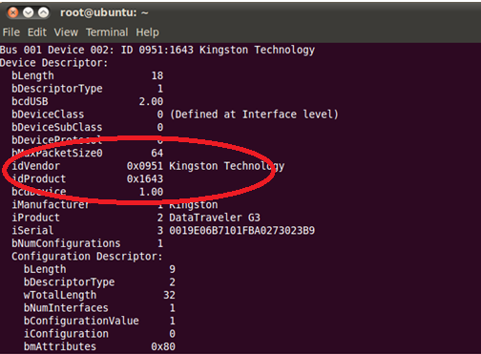

1. In order to have further information about your device use the command **“lsusb –v”.**
2. Make a new directory by using the command **mkdir newdir.**
3. And then move to that directory by using the command “**cd newdir**”.
4. No create your .c file and then Makefile which will ultimately be formed inside your directory (.c file and Makefile are there in the attachments).
5. Open that .c file using the command “**gedit filename.c”**
6. Now find “static struct usb_device_id usb_table[]” and check inside. Then find the “USB_DEVICE(**0xaaaa, 0xbbbb**)” function. Rewrite your vendor Id and Product Id over here. For example these ID’s can be anything as it varies from device to device let’s assume that your Vendor Id is 1234 and Product is 2244 then you will change it to USB_DEVICE(0x1234, 0x2244). This way the device driver will recognize your ID. You may disconnect the USB now. The usage of ‘0x’ before the vendor and product ID is a must since it will specify that these ID’s are in hexadecimal form.
7. Compile the module using the command “make”.
8. Now insert the module using “**insmod ./filename.c**”
9. Now remove the original USB driver of Ubuntu by the command “**rmmod usb_storage”** or “**rmmod usb-storage**” (Either of these command can work due to different versions of Linux)
10. Make sure no devices are connected to all of your USB ports.
11. Now connect your USB and then type the command “**dmesg**”. Here you can see the printk statements of the Prob function as well as printk statements of init function. It means that our driver is installed and in hold of the usb.
12. In dmesg you can see the number of endpoints and types of endpoints etc too. We’ve printed them in the prob function. And to check if it is correct you use the command “ **cat /sys/kernel/debug/usb/devices”.** Here the E rows are showing endpoints.

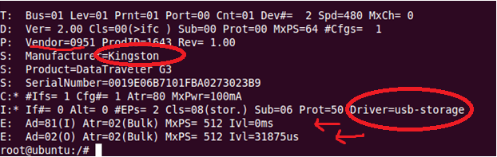

1. To verify again that your device driver is in control you can use the command

“**cat /sys/kernel/debug/usb/devices**”. Here find your devices and in the ‘I’ row, check the last column you can see that the driver name will be our device driver named as **“USB Device Driver by Elsa, Abubakar and Fahad”**. It shows that our driver is controlling the device.

